Walkthrough - Template

Contents

Host Discovery 2

Nmap 2

Nikto 2

Dirb 2

FFuf 2

Gobuster 3

Burp Suite 3

Viewing Website 4

Exploitation 4

Escalation 5

Upgrade Shell 5

Flag 1 5

Flag 2 5

Sudo -l 5

# Host Discovery

**Kali**: 192.168.56.101

**Victim**: 192.168.56.155

# Nmap



# Nikto



It found nothing interesting.

# Dirb



# FFuf

# Gobuster

# Burp Suite

I don’t quite understand why, however adding “X-Forwarded-fo” to the request can bypass something.

The response I need, -------->

Right click the response then click request in browser > current browser session.

I will try some basic credentials admin:admin, and it worked.

Move this result to the main web-browser and see now you have logged in.

# Viewing Website

The website shows that it can allow file uploads. I tried upload my reverse php shell however the extension is not permitted. I will try and modify it.

# Exploitation

I now will upload my reverse php3 shell.

In the url: <http://192.168.56.155/adminstration/upload/files> The file was located.

# Escalation

## Upgrade Shell



# Flag 1

It is a base64 text.



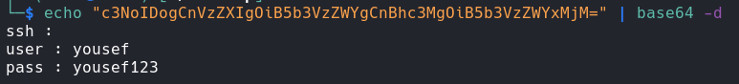

# Flag 2

## A screen shot of a computer Description automatically generatedSudo -l

